**TASK 8 TEST 3**

**MUTATIONS AND GENE POOLS**

**Section One: Multiple-choice /10 marks**

**Section Two: Short answer /28 marks**

**Section Three: Extended Answer /18 marks**

**TOTAL: /56 marks**

Name: _**MARKING KEY**

Select the best alternative from the answers given and mark your choice like this

#. (b) (b) (c) (d)

|  |  |
| --- | --- |
| 1. (a) **(b)** (c) (d)  2. (a) (b) **(c)** (d)  3. **(a)** (b) (c) (d)  4. **(a)** (b) (c) (d)  5. (a) (b) (c) **(d)** | 6. (a) **(b)** (c) (d)  7. **(a)** (b) (c) (d)  8. (a) **(b)** (c) (d)  9. (a) **(b)** (c) (d)  10. (a) (b) **(c)** (d) |

**Section Two: Short answer**

**Question 1**

1. Explain how the Bottleneck effect caused a large number of colour blind individuals in Pingelap during the 1800’s and 1900’s after a typhoon wiped out all but 20 inhabitants?

Natural disaster [typhoon] created a small (isolated) sample of original population

This sample is not genetically representative of original population

With one individual carrying the gene for colour blindness [achromatopsia]

Restricted breeding/inbreeding existed among the population

This resulted in the frequency of the colour blind gene to increase/ maintain over time

(4 points for 4 marks)

1. Suggest a factor that could have changed in the 1900’s to result in the reduced incidence

of genetically-inherited colour blindness in the Pingelap population.

(increased) migration from the mainland to the island

interbreeding/gene flow with the mainland that increased breeding

random genetic drift/chance events

(any 1 for 1 mark)

Dr Bruce’s misplaced slides

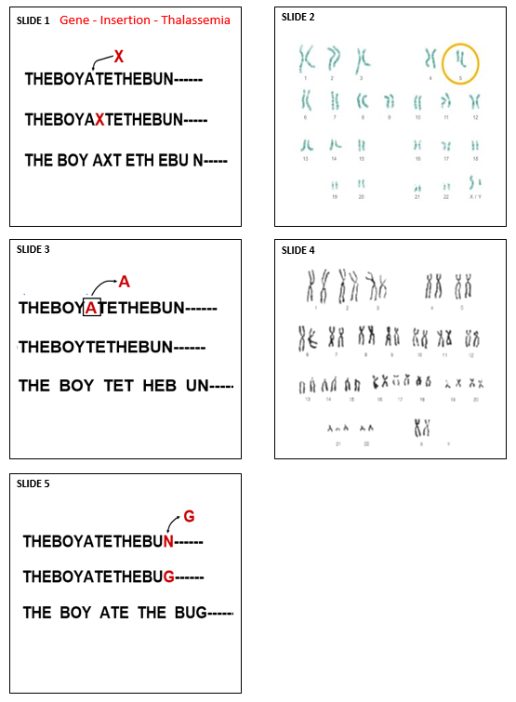

**Question 2**

Dr Bruce was preparing a series of medical lectures on mutations, but he accidentally left a draft copy of some of his unfinished numbered power point slides lying around [see attachment]. Can you add the extra information he is missing using the table below to help him out? Slide 1 has been completed as an example for you to follow.

|  |  |  |  |  |
| --- | --- | --- | --- | --- |
| Slide Number | Mutation | Mutation type | Mutation description | Disease |
| 1 | Gene | Insertion | a nucleotide has been inserted into the DNA | Thalassemia |
| 2 | **Chromosome** | **Deletion / Partial monosomy** | **part of chromosome 5 is missing** | **Cru du chat syndrome** |
| 3 | **Gene** | **Deletion** | **A gene is missing/deleted** | **Tay-Sachs disease/ skin colour / cystic fibrosis** |
| 4 | **Chromosome** | **Non-disjunction** | **Trisomy or extra chromosome** | **Down syndrome** |
| 5 | **Gene** | **Substitution** | **A nucleotide has been replaced [A for T]** | **Sickle cell anaemia** |

(8 marks)

**Question 3**

The incidence of genetic diseases in certain populations illustrates the effects of different factors on the dynamics of gene pools.

1. Outline 2 conditions that are required to lead to an increased incidence of a particular genetic disease within a population.

The mutation needs to be an inherited non-fatal disease (that can be passed on) (1)

Isolated/ small reproduction pool (1)

There needs to be a selective advantage to the gene (1)

(any 2 for 2 marks)

1. A mutation is another type of evolutionary mechanism that can affect frequencies of alleles in populations. Explain the difference in consequences between a mutation occurring in a somatic cell and one occurring in a germ cell

Somatic mutations only affect the individual (1)

Germ cell mutations occur in the gametes and are passed on to the next generation (are

inheritable) (1)

(2 mark)

**Question 4**

1. Name the disease that causes irregularly shaped red blood cells, pain and fatigue.

Sickle Cell Anaemia (1)

1. What population is it most common in?

African and African American (1)

1. What other disease does this disease help protect against?

Malaria (1)

1. Explain why this disease is not prevalent in Australia

Australia is free of Malaria (1) therefor the mutation gave no genetic advantage (1)

(2 marks)

**Question 5**

Tay-Sachs disease is a disorder of lipid metabolism which occurs as a result of a gene mutation. The recessive allele prevents the gene from producing a protein that will be able to function in the body. These recessive mutations are considered `lethal recessives’, and in the case of the Tay-Sachs disease, this leads to the death of the embryo or foetus, or the early death of a child.

Using examples, explain how a lethal recessive mutation such as the Tay-Sachs disease brought about changes in the gene pool through the following two evolutionary mechanisms:

1. genetic drift

TS disease has higher occurrence in Ashkenazi Jews in Eastern Europe (1)

Ashkenazi Jews population was small and isolated (1)

Both geographically and culturally (only marry within the community). (1)

This increased the chance of genetic drift through the founder effect (1) (explains why a rare allele becomes more frequent in small populations).

(4 marks)

1. natural selection

Individuals with two (homozygous recessive) Tay-Sachs alleles would die early in life (1)

While individuals with two normal (homozygous dominant) alleles would be more susceptible to TB, and would possibly die due to TB before reproducing (1)

Heterozygotes, on the other hand, would have increased resistance to TB and therefore have a survival advantage passing their alleles on to the next generation. (1)

Over time, the gene pool would have more Tay Sachs alleles /frequency of TS allele increases. (1)

(4 marks)

**Section Three: Extended Answer**

**Question 1 (10 marks)**

One physical variation found in human populations is skin colour. Skin colour changes gradually with distance from the equator. Describe this variation in skin colour and discuss the process by which natural selection has established this gradual change.

There is variation in skin colour within the human population [1].

Dark towards the equator /lighter shades or colour away from the equator [1]. Environments differ in terms of UV radiation [1].

This acts as a selective pressure [1].

Dark skin has a selective advantage near the equator [1].

as protection from UV radiation and therefore skin cancer protection [1].

Also protects against damage to folate which decreases chances of NTD (1)

Pale skin has selective advantage away from the equator [1]

maximum UV radiation can be obtained for vitamin D production [1].

Vitamin D is essential for proper bone growth/ Low vit D can cause rickets (1)

Those with the variation that offers the selective advantage are more likely to survive and have offspring [1].

**Question 2 (10 marks)**

Some scientists believe that Homo antecessor may be the common ancestor of Homo sapiens [modern man] and Homo neanderthalensis. Describe the processes through which speciation may have occurred in producing two species.

**Variation (max 2)**

a population exists on an island. (1)

A range of variations exists within the population, which shares a common gene pool. (1)

**Isolation (Max 3)**

the species is divided into two populations. (1)

A barrier has formed, dividing the population into two. (1)

No interbreeding occurs between the two populations. (1)

Each population has a separate gene pool. (1)

**Selection** **(Max 3)**

Different selection pressures act on each of the two populations over a number of generations (1)

This brings about a change in the gene frequencies of each gene pool. (1)

Such changes lead to the evolution of separate subspecies. (1)

**Speciation** **(Max 2)**

Over a long period of time the changes in the gene frequencies is great enough to prevent interbreeding between the two populations from producing fertile offspring. (1)

When this happens, two species exist. (1)

Explain how the process of natural selection can lead to a particular phenotype

becoming prevalent in a population. (10 marks)

Description Marks

**Variation**

variation present in individuals/many phenotypes present 1

wide variety of genes/large gene pool present

**Subtotal 1**

**Struggle**

**overproduction of offspring**

1–3

limited resources available

selection pressure present

competition for resources/struggle to survive

**Subtotal 3**

**Selection**

**genes passed to offspring**

1–6

a particular phenotype is more suitable for the environment

individuals that do not possess the phenotype (genes) die-off

individuals that do possess the phenotype (genes) survive/survival of the

fittest

over time more individuals have more suitable characteristics

after many generations the particular phenotype is more prevalent

can produce speciation

Subtotal 6

Total 10